**User Generated Content Analytics**

**Analysis of Edmunds.com**

1. **Task A:** For the 10 brands you have chosen, calculate the lift ratio for associations between the brands. Use the python script liftcalculations.py to calculate lifts.

Show the brands on a multi-dimensional scaling (MDS) map.

What insights can you offer brand managers from your analysis in Task A?

1. Which forum you chose (provide URL)

* I used following URL to find 5500 user comments about “Entry Level Luxury Performance Sedans” from one of the famous car forums “edmunds.com”.

URL 🡪 [https://forums.edmunds.com/discussion/2864/general/x/entry-level-luxury- performance-sedans/p](https://forums.edmunds.com/discussion/2864/general/x/entry-level-luxury-%20%20%20%20%20%20%20%20%20%20%20%20%20%20%20performance-sedans/p)

1. Which 10 brands you chose and why?

* After collecting user comments, I ran word frequency program to find out the number of occurrences of relevant words in those 5500 comments. And on the basis of high number of occurrences chose top 10 car selling brands. (For example, BMW word has been occurred 1714 times in the collected 5500 comments.)

|  |  |
| --- | --- |
| **Brand Name** | **Frequency of Appearance in comments** |
| BMW | 1714 |
| Acura | 766 |
| Audi | 709 |
| Infiniti | 575 |
| Lexus | 409 |
| Honda | 395 |
| Mercedes | 222 |
| Pontiac | 337 |
| Nissan | 213 |
| Toyota | 214 |
|  |  |

1. Show all lift ratio calculations in a table.

* Here, Lift is nothing but the potential of association between the given two car selling brands. So, assumptions are,
* Lift > 1; Higher Association, so larger the value; strong will be the Association
* Lift < 1; Lower/negative Association
* Lift = 1; both are independent of each other.

|  |  |
| --- | --- |
| **Brand Relation** | **Lift Value based on Association** |
| Toyota & BMW | 1.31953452 |
| Toyota & Acura | 1.98600265 |
| Toyota & Audi | 1.63123089 |
| Toyota & Infiniti | 2.32425711 |
| Toyota & Lexus | 3.7074661 |
| Toyota & Honda | 4.94498702 |
| Toyota & Mercedes | 3.93618654 |
| Toyota & Pontiac | 2.13538786 |
| Toyota & Nissan | 4.70581592 |
| BMW & Acura | 1.26930454 |
| BMW & Audi | 4.94264066 |
| **Brand Relation** | **Lift Value based on Association** |
| BMW & Infiniti | 1.60722351 |
| BMW & Lexus | 1.89079881 |
| BMW & Honda | 1.26730023 |
| BMW & Mercedes | 4.07073306 |
| BMW & Pontiac | 1.32353914 |
| BMW & Nissan | 0.99429671 |
| Acura & Audi | 2.24823177 |
| Acura & Infiniti | 5.58706037 |
| Acura & Lexus | 5.0260096 |
| Acura & Honda | 2.53444308 |
| Acura & Mercedes | 1.90824035 |
| Acura & Pontiac | 1.24588391 |
| Acura & Nissan | 2.220436 |
| Audi & Infiniti | 2.01017955 |
| Audi & Lexus | 2.40877952 |
| Audi & Honda | 1.88534465 |
| Audi & Mercedes | 4.51828323 |
| Audi & Pontiac | 1.58831256 |
| Audi & Nissan | 1.05617254 |
| Infiniti & Lexus | 1.89079881 |
| Infiniti & Honda | 1.26730023 |
| Infiniti & Mercedes | 4.07073306 |
| Infiniti & Pontiac | 1.32353914 |
| Infiniti & Nissan | 0.99429671 |
| Lexus & Honda | 1.94051544 |
| Lexus & Mercedes | 3.81616758 |
| Lexus & Pontiac | 1.75574744 |
| Lexus & Nissan | 1.7046055 |
| Honda & Mercedes | 2.25795308 |
| Honda & Pontiac | 1.4048002 |
| Honda & Nissan | 3.80769612 |
| Mercedes & Pontiac | 1.61734309 |
| Mercedes & Nissan | 2.09364453 |
| Pontiac & Nissan | 2.22203458 |
|  |  |

1. Show the MDS map.

* Based on the calculated lift (similarity) values, I calculated the dissimilarity values by dividing each lift value by 1. These dissimilarity values have been provided as an input matrix for plotting MDS map.

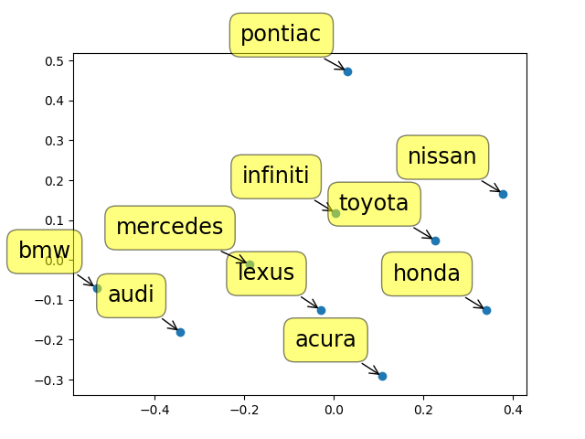

1. Insights to brand managers.
2. To BMW brand manager

* For BMW, close rivals are Audi and Mercedes. Whenever people talk about any model of BMW, most of the times they compare it with respective models of Audi and Mercedes.

1. To Acura brand manager

* For Acura, most close competitors are Lexus, Infiniti, and Toyota. Here, I have not mentioned Honda, as Acura is a marque of Honda. All these competitors are also famous for selling a luxurious cars like Acura. So, to be the best among all of them, with luxury, you have to focus more on factors like performance, power and cost.

1. To Lexus brand manager

* Lexus brand is pretty famous among the people. As per the MDS map Lexus is almost at the center. It means usually all the people who are looking for performance, power based car or people looking for luxury based car, always talk about Lexus models. So, even if Lexus is attracting the users who are in fever of buying cars of more famous brands like BMW, Audi, and Mercedes, they have to raise their standards so that these users not just talk but should buy Lexus cars more often.

1. To Nissan brand manager

* Nissan models are mostly compared with models of Infiniti, Toyota, and Honda. If Nissan raised the standards of their cars they can compete with more famous brands like BMW, Mercedes, Lexus, and Audi.

1. To Pontiac brand manager

* Pontiac is the brand which is least associated with any other brands of cars. Even though people more frequently talk about Pontiac as a brand and about its models, most of the comments were more limited to Pontiac. People not prefer to compare it with the models of other car brands.

1. To Honda brand manager

* Lexus, Toyota, Nissan are the closest competitors of Honda. Whenever people look for entry type sedans they usually compare Honda sedan cars with other luxury car models of Lexus, Toyota, and Nissan. So by producing higher end models they can definitely compete with brands like Mercedes, Audi.

1. **Task B:** Pick 5 most frequently mentioned attributes from the posts. Which brands (choose the 5 most frequently mentioned instead of 10) have the highest association with these attributes? E.g., Audi with style, BMW with performance, etc. (these are just examples, the reality can be very different).

What advice will you give to a (i) product manager of these brands based on your analysis in Task B?

1. Which forum you chose (provide URL)?

* I used following URL to find 5500 user comments about “Entry Level Luxury Performance Sedans” from one of the famous car forums “edmunds.com”.

URL 🡪 [https://forums.edmunds.com/discussion/2864/general/x/entry-level-luxury- performance-sedans/p](https://forums.edmunds.com/discussion/2864/general/x/entry-level-luxury-%20%20%20%20%20%20%20%20%20%20%20%20%20%20%20%20%20%20%20%20%20%20%20%20%20%20%20%20%20performance-sedans/p)

1. State the attributes and the basis of their selection.

* After collecting user comments, I ran word frequency program to find out the number of occurrences of relevant words in those 5500 comments. And on the basis of high number of occurrences chose top 5 most talked about attributes of a car. (For example, Power word has been occurred 701 times in the collected 5500 comments.)

|  |  |
| --- | --- |
| **Attribute Name** | **Frequency of Appearance in user comments** |
| Power | 701 |
| Performance | 629 |
| Interior | 592 |
| Cost | 418 |
| Luxury | 404 |
|  |  |

1. Show all lift ratio calculations in a table.

|  |  |
| --- | --- |
| **Brand & Attribute Relation** | **Lift Value based on Association** |
| BMW & Power | 3.30551194 |
| BMW & Performance | 4.73410878 |
| BMW & Interior | 2.48431774 |
| **Brand & Attribute Relation** | **Lift Value based on Association** |
| BMW & Cost | 1.67352533 |
| BMW & Luxury | 1.50912189 |
| Acura & Power | 1.79247769 |
| Acura & Performance | 1.57529683 |
| Acura & Interior | 1.72226719 |
| Acura & Cost | 1.52879018 |
| Acura & Luxury | 3.34460465 |
| Audi & Power | 3.89783008 |
| Audi & Performance | 1.65261121 |
| Audi & Interior | 6.60005016 |
| Audi & Cost | 1.59602144 |
| Audi & Luxury | 4.4977781 |
| Infiniti & Power | 1.92396121 |
| Infiniti & Performance | 1.6271513 |
| Infiniti & Interior | 1.7611618 |
| Infiniti & Cost | 1.94507876 |
| Infiniti & Luxury | 3.96000396 |
| Lexus & Power | 2.82833425 |
| Lexus & Performance | 2.48673946 |
| Lexus & Interior | 1.77178992 |
| Lexus & Cost | 2.02676546 |
| Lexus & Luxury | 3.12886219 |
|  |  |

1. Show the MDS map.

* Based on the calculated lift (similarity) values, I calculated the dissimilarity values by dividing each lift value by 1. These dissimilarity values have been provided as an input matrix for plotting MDS map.

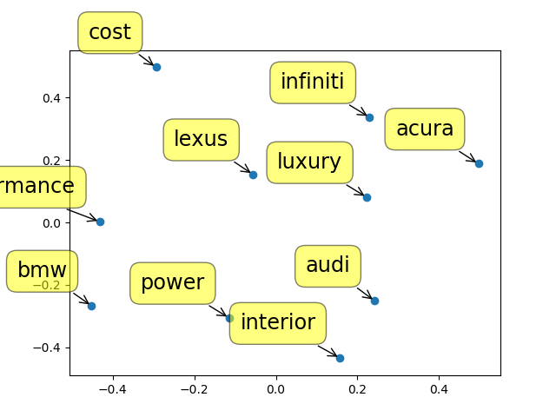

1. What advice will you give to a (i) product manager of these brands based on your analysis?
2. To BMW product manager

* Whenever people talk about BMW, comments are mainly about performance and power. People are very happy/satisfied with the provided performance and power. For BMW, closest competitors are Audi and Lexus. Audi is more famous for interior and power what they provide. Lexus is more about luxury. So, in order to compete with these brands and to win the battle, BMW should focus on attributes like interior, luxury along with their best performance.

1. To Audi product manager

* Audi as a brand, is known for its powerful and stylish interior designed automobiles. Interested people always accolades about Audi’s powerful engines and beautiful interiors. Audi is getting considered more as a luxury brand than a performance machine. Other brands like BMW, Lexus, and Acura are competing with Audi to make a mark in automobile industry. According to the analysis, along with power and interior, Audi should focus on performance more precisely on mileage factor to compete with BMW.

1. To Lexus product manager

* Lexus is being consider more as a luxury brand than performance or powerful automobile. For Lexus, close competitors are Infiniti and Acura. As both Infiniti and Acura are known for their luxury cars, Lexus has to improve its luxury standards as well as has to focus on other attributes like power, interior. There are two advantages of doing this, first, Lexus will beat its competitors like Infiniti, Acura. And second, it can attract the customers who are looking for performance, interior, and power. So Lexus may give tough competition to brands like BMW, Audi.

1. To Infiniti product manager

* Whenever people talk about Infiniti they talk about its luxury. So being as a luxury brand, Lexus and Acura are the competitors of Infiniti. Infiniti has to improve its luxury standards as well as has to focus on other attributes like power, interior. Infiniti can also focus on factors like Safety, reliability to become a more aspirational brand among the rest.

1. To Acura product manager

* Acura is famous among the people as luxury car brand. Whenever people talk about Acura they talk about Lexus, Infiniti and their luxury standards. In order to beat the competitors Acura has to raise its luxury standards as well as has to focus on other measures like performance, power, safety, and power.

1. To all product managers about cost measure

* All the brands have a variety of entry level luxury sedan car models. People are least interested in comparing prices because all these brands sell out their luxury cars for about same cost. If any production unit tries to reduce the cost of production which eventually cut down the selling price, may get benefited by drawing customers’ attention.

1. **Task C:** Which is the most aspirational brand among the top 5? How did you find the answer? Show all steps.

* **Audi** is the most aspirational brand among the brands like BMW, Lexus, Acura, Infiniti and Audi.

1. Brand association analysis shows that Audi has a high associations (i.e. high lift values) with BMW, Mercedes, Acura, and Lexus. From these associated brands BMW, Acura, Lexus are one of the top 5 most talked about brands. So, Audi is highly associated with majority of the most talked about brands.
2. Among 5500 car forum user comments, Audi is just behind the two most frequently talked about brands (BMW 1714, Acura 766, Audi 709).
3. Brand Attribute association analysis shows that Audi has the greatest associations with interior (L (Audi, interior) = 6.6000502), power (L (Audi, power) = 3.8978301), and luxury (L (Audi, luxury) = 4.4977781) than any other brand. This proves that Audi has a highest association with majority of the most talked about attributes in automobile industry.
4. As we are considering all 5500 comments have positive sentiments, people looking for best interior, power, and overall luxury found Audi as their best choice.
5. In terms of performance, among the top 5 most talked about brands, Audi is just behind of BMW and Lexus.